**Children’s Art with Meditation**

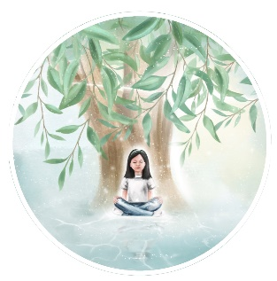

**Instructions**

Distribute paper, pens, colouring pencils, paints or other art materials that you have available so that each child has a selection of colours in front of them. If you have any gold or silver paint or glitter keep it back for later.

Allow your child or children to make themselves comfortable, sitting crossed leg on the floor or outside on the grass on mats or cushions or on a chair with a table nearby with the art materials.

Play relaxing music of your choice in the background (for example soft classical music, natural sounds or easy listening) at a level at which you can still be heard when you talk.

Then ask the children to gently close their eyes and read out the following meditation very slowly:

MEDITATION

*Feel yourself becoming very quiet, still and peaceful*

*Feel the peace and quiet flowing through you*

*Listen to the sound of your breathing*

*You are feeling more and more relaxed and peaceful*

*with every breath in and out that you take*

*Think of the word LIGHT (pause for at least 10 seconds)*

*See a ball of golden light in the centre of your chest*

*The ball of light is expanding*

*as you feel more peaceful, the light fills up your body, your head, your arms and legs*

*You are filled with light from the top of your head to your toes*

*There is so much light inside of you that you can send it out to anyone you wish*

*You can send it to everyone in your road, your City or your Country*

*Or even to every person in the whole world*

*Now listen to the music playing and keep thinking about LIGHT*

*When I turn off the music, open your eyes, look at your paper, and put on it the first line or shape that comes into your mind.*

*Keep concentrating on your paper and the most beautiful things will grow out of your shape or line.*

Turn off the music and indicate to the child/children to start drawing or painting if they have not already done so.

When their drawing or painting is almost complete, offer them some gold or silver paint or glitter to decorate their creation.

Please take a photo of the drawing or painting.

If you wish to share the drawing or painting online to inspire others, please email the photo to [michelle.sorrell@virgin.net](mailto:michelle.sorrell@virgin.net).